Image | 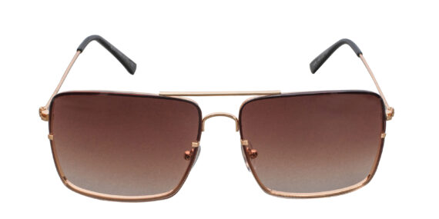
Brand | PRADA
Model Name | Estrella FSG
Price | RS 2000
PRODUCT DETAILS

